

Dublin College Dundrum
STUDENT IT HANDBOOK
2026/27

1.0 College Computers 1
1.1 College Networks 1
1.2 Your College Username & Password (Microsoft 365) 1
1.3 Resetting Your Password 2
2.0 Microsoft 365 Account 2
2.1 Logging in to Microsoft 365 the First Time 2
3.0 Accessing your College Email for the First Time 9
3.1 Download Microsoft Office Software to Your Home Computer/Device (Free) 10
4.0 Storing Coursework - Microsoft 365 OneDrive 12
4.1 How to Upload a Word file from a Computer’s Hard Drive to the OneDrive 14
4.2. Sharing files from your OneDrive 15
5.0 Printing in DCFE 15
5.1 Generate Your Printing PIN 15
5.2 Printing through browser 17
6.0 Help & Support 18

Appendix - Other Microsoft and Moodle Training Materials…………………………………………………………18

1.0 College Computers
Throughout the academic year, you can use college computers or laptops or bring in and use your own laptop / tablet. To print documents, you can use the printers in selected classrooms or you can print to the photocopiers in the common areas.
For Induction Students need to start with Guest Account which requires no password. After setup of own accounts, you can log in to computers with own account
(Note : You will need a pin for the all printers See Section 5 on Printing for detailed instructions)

1.1 College Networks
The desktop machines throughout the college are on a wired Local Area network. For Wifi devices the following wireless network can also be used.
Network: DDLETB_Temp
Password: askaboutwireless

1.2 Your College Username & Password (Microsoft 365)

Your college(office365) username and password will be emailed to you at the start of the academic year.
It will be emailed to the ’ personal’ email you provided in registration process (gmail / yahoo/ Hotmail
/ outlook etc.) Originating from noreply@tools4schools.ie with the subject Welcome to Dundrum CFE
You will need to change it first time and also setup authentication for remote use (See steps below)
This username and password will be required to log into any college desktop or laptop computer, Microsoft 365 and Moodle and for printing purposes
Note the Microsoft 365 username and password is separate to the username and password for the eNROL system which was separately be emailed to your ‘personal’ email (gmail / yahoo/ Hotmail / outlook etc.) from smtrelay@mit.ie entitled ‘Successful Application Submission. It will also be in your Offer
Letter.
“eNROL” system. eNROL is where you pay your €50.00 acceptance fee, complete the Learner Detail Form and upload documentation such as, ID, LC results, medical card and your photo etc.
It is important to check your personal email for both of the username and password mentioned above

- Your email address is your 8-digit username followed by @dundrum.mycollegedundrum.ie E.g. 20245678@dundrum.mycollegedundrum.ie

- Your email address password will consist of a combination of numbers, letters and special characters, and is case sensitive. E.g. aA*12#zZ

Your college email address and password will be used to log in to:
Any college computer / college laptop
Microsoft 365 applications
Moodle LMS (via OpenID Connect)

1.3 Resetting Your Password

After your initial setup password can be reset by selecting Forgot Password. For additional support contact your Programme Lead .
Iin the event of an issue with ENROL password contact your Programme Lead

2.0 Microsoft 365 Account (Note screen prompt may get updated)

2.1 Logging in to Microsoft 365 the First Time

On your internet browser, go to the college website and student area https://cfedundrum.com/my-dcfe/

- Scroll down the page and Click on the Microsoft 365 logo as shown below

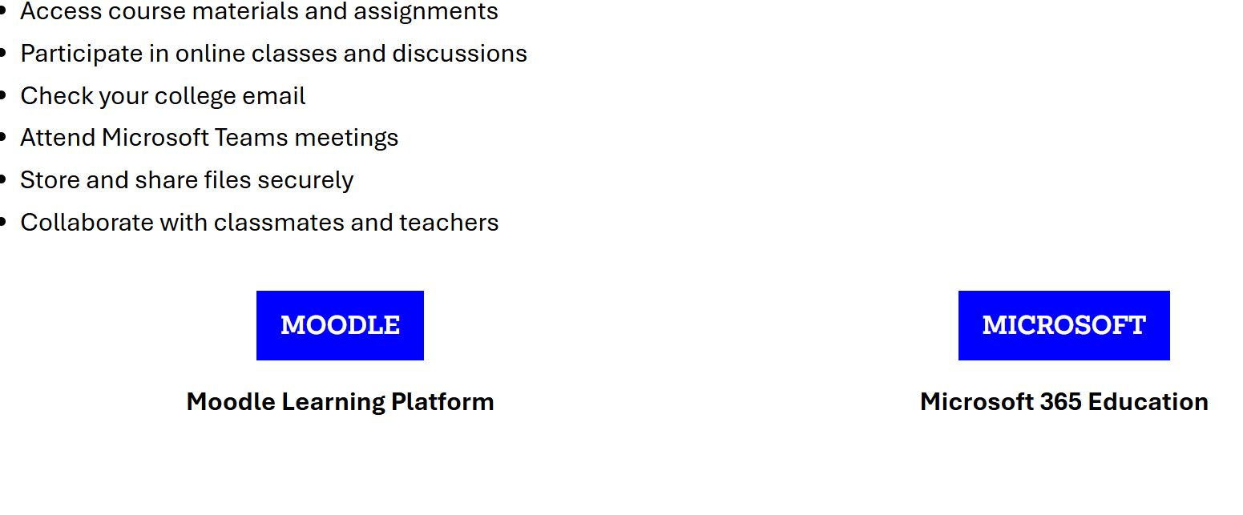

- Note There may be slight variations in the sequence of steps below presented to you as you go through the account setup. This is to do with Microsoft rather than the college but the main thing is to complete your authentication method so that you can access your account and other systems remotely as linked to your Microsoft account. If you are unable to complete this step, please refer to your Programme Lead

- Enter your college email address.

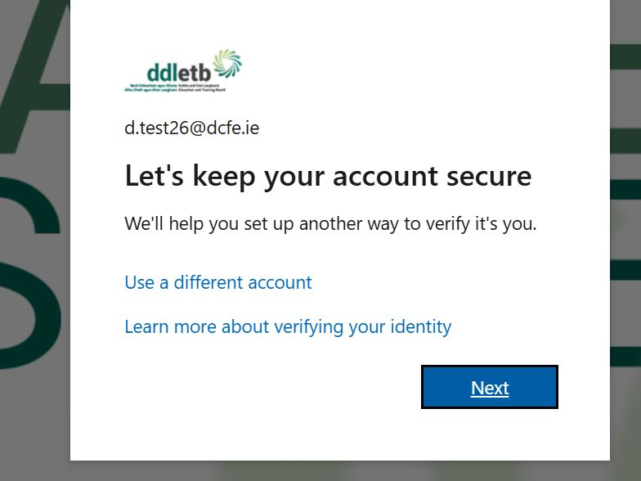

- Click Next

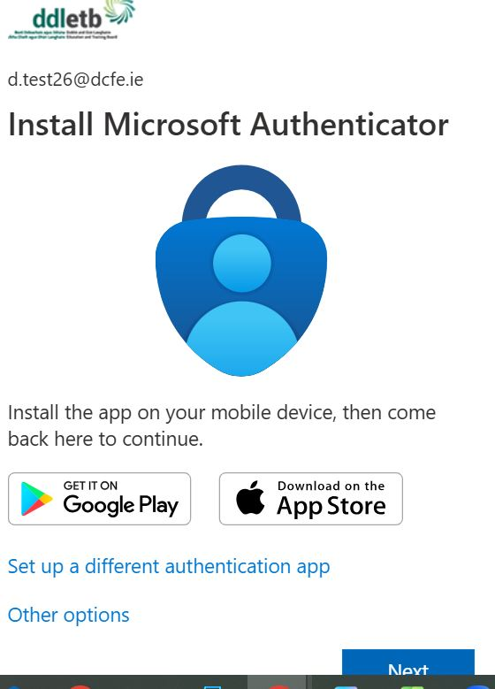

- You are now ask to set up secondary security check on your phone. You can either use the official Microsoft APP or click Other options to just have a code direct to your phone by text (Code direct to phone is the preferred by the college as simpler). Select Phone to add your number

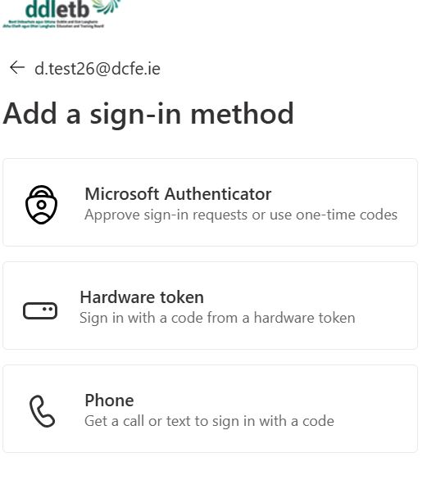
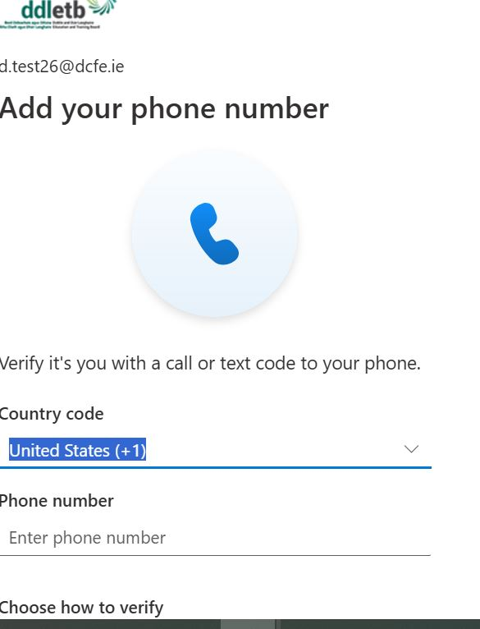
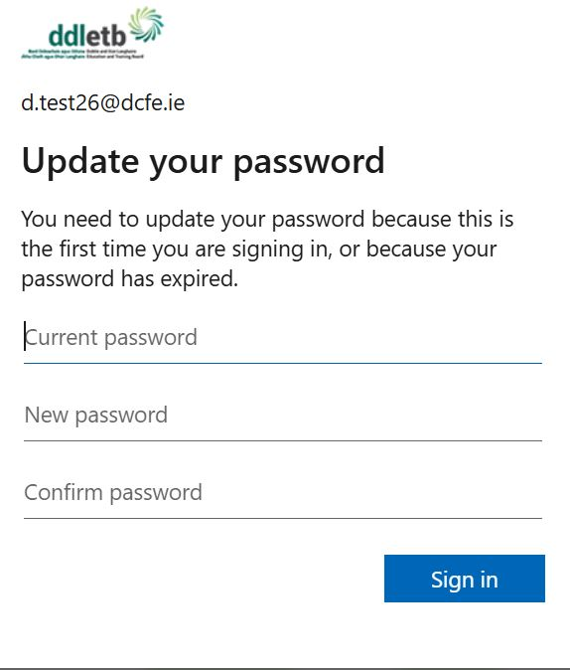

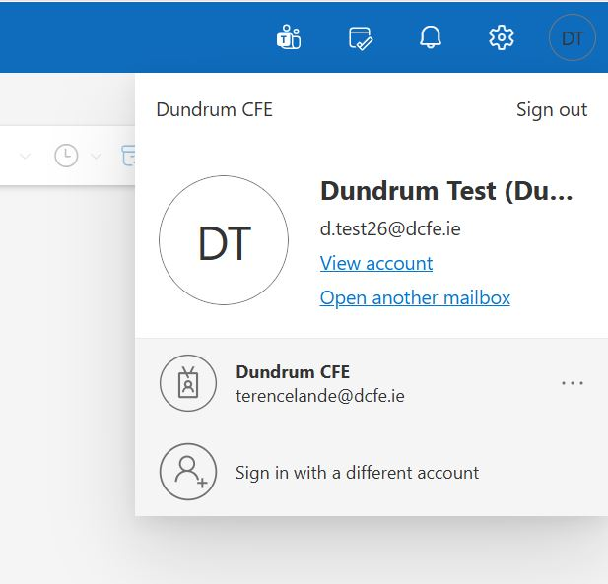

To check all is setup view account

And then click to your security info . You can change your authentication phone number here for example if you change during the year

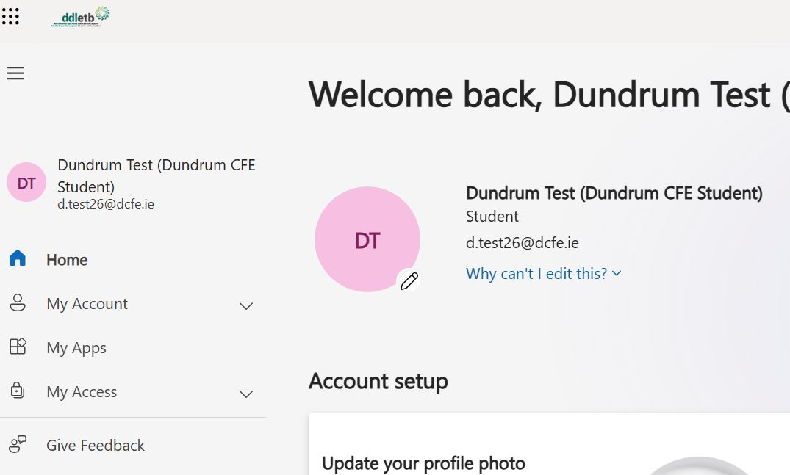

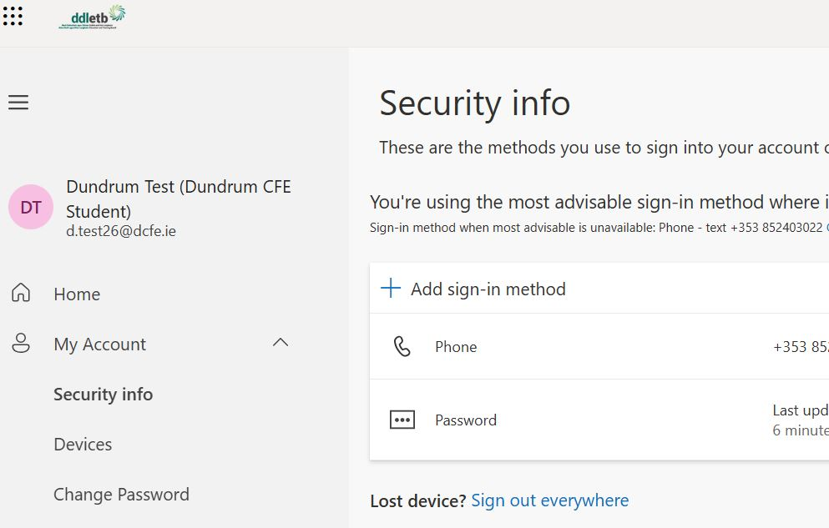

- From your 0365 account page you can navigate to your apps (Email, word etc) via the 9 dots as shown below

3.0 Accessing your College Email for the First Time

- Once logged in to Microsoft 365 t, click the app launch icon (i.e. the 9 dot grid on the top left corner). It will display all the apps within the Microsoft 365 program.
- For email, select ‘Outlook’.

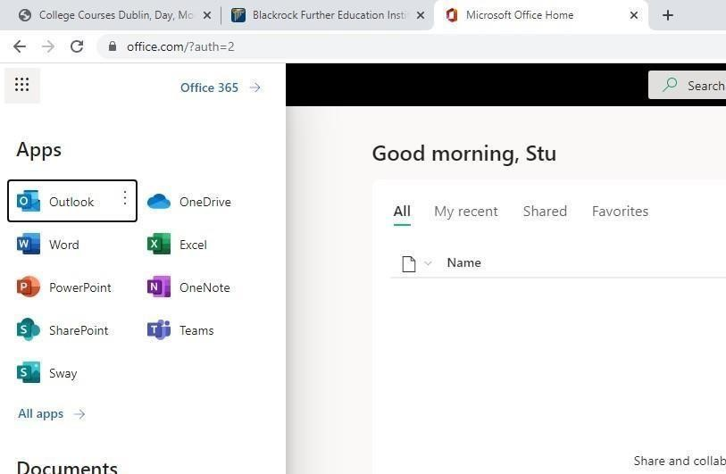

Click the App Launch Icon

Click Outlook

Note: This email account will be used by all staff to contact students and likewise you must use only this email account to communicate with both staff and students in DCFE so you should check your college email every day/morning.

You can download the ‘Outlook’ app on your phone so you can be alerted when college emails come in.

3.1 Download Microsoft Office Software to Your Home Computer/Device (Free)

As a student of DCFE, you are provided with 5 free Microsoft 365 Office Software licences. This means you can install Microsoft Office software on 5 separate personal/ home devices and thereby get access to the full “Desktop versions” of Word, Excel, PowerPoint, Outlook etc. for the academic year.
While the ‘online’ versions of Word, PowerPoint etc. are often sufficient for basic coursework, you may need also access to more functionality and features of the Office the ‘Desktop’ versions for other work (E.g. Word Processing or Spreadsheet classes).

NB. You must log into your college Microsoft 365 account on your home computer/device in order to download the free desktop software to the hard drive of that particular device.

1. On your home computer/device, open an Internet browser and log into your Microsoft 365 account
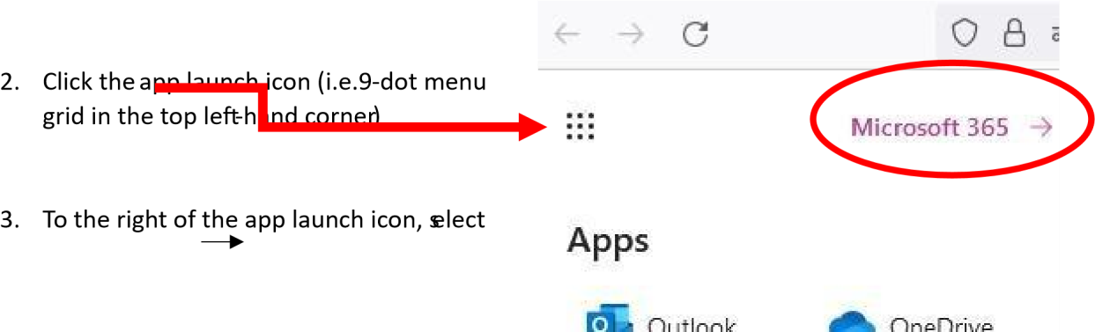

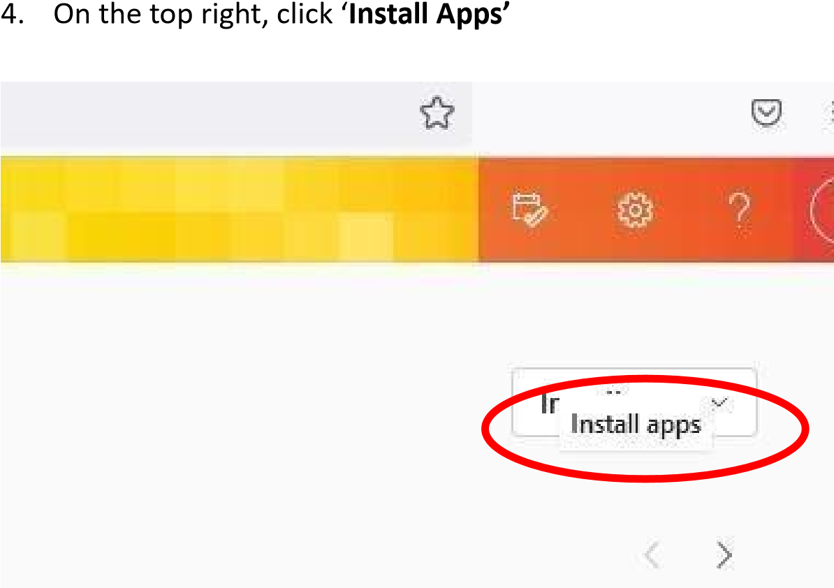

- Select Microsoft 365 apps and when prompted, Save File
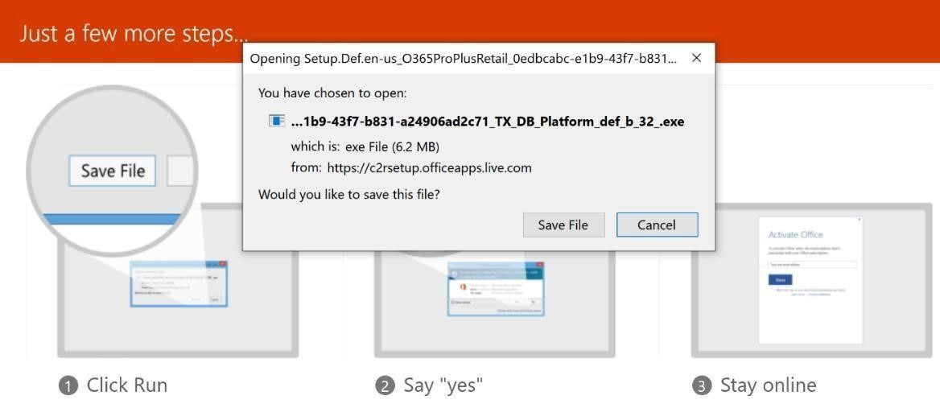

- Run the saved .exe file and follow the prompts to complete the download.

4.0 Storing Coursework - Microsoft 365 OneDrive

Storing Coursework:
- All students are required to store all college coursework ONLINE throughout the year. You will be using moodle for your Assessment but you can store college work as you go on your Microsoft 365 OneDrive which is accessible using your college username and password.

- Students should NOT save their work to the hard drive of college computers (i.e. NEVER save your files to “This PC” in places such as ‘Desktop’ or ‘Documents’ or ‘Downloads’ or ‘Pictures’) as you may not be able to access this work later. USB storage devices/memory sticks are not recommended for storing college work as they can get lost, left in computers and/or corrupted.

- Note, all student accounts (Microsoft 365, DCFE network, Moodle,) will be disabled at the end of School Term when the academic year is complete. All student files stored on these accounts will no longer be accessible. Students should back-up, on their personal cloud storage, any college files they wish to retain before the end of the academic year.

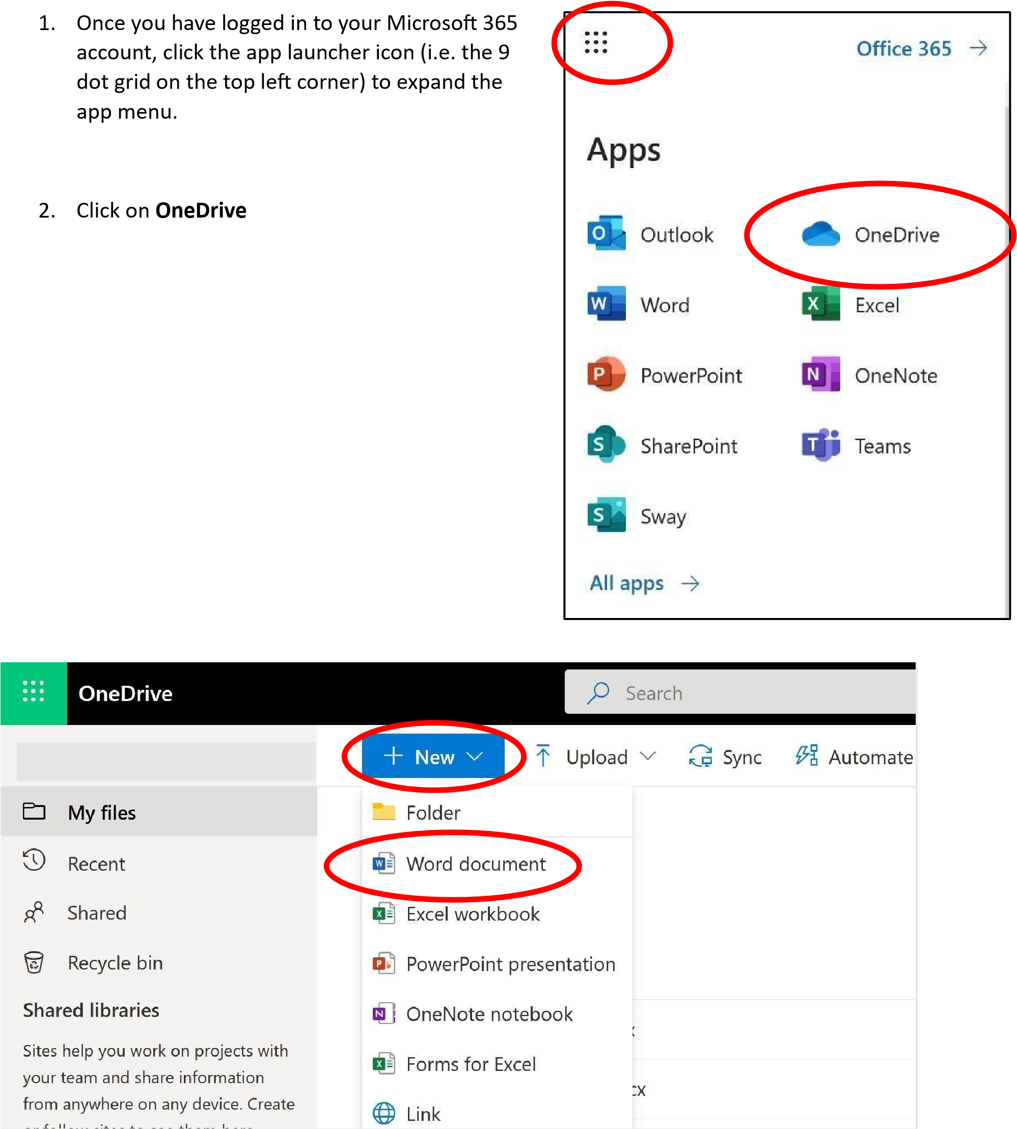
1. Give this new document a title by clicking where in the top left where it says ‘Document1’ or ‘Document2’ etc. and typing a new file name to replace this one. See example below.
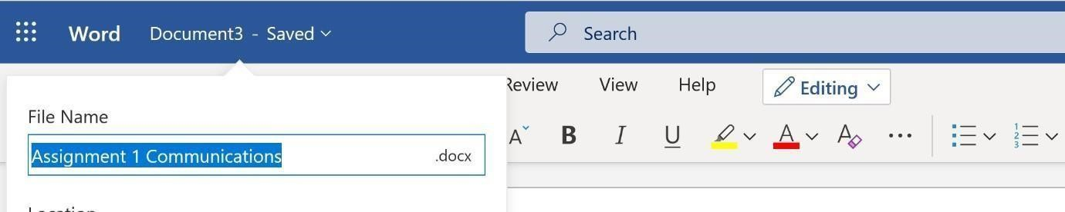

As you type in the online version of MS Word, your work is automatically saved as you type. You can close out at any time and the last text you typed will be saved. This document is also accessible anywhere you have Internet access and open Microsoft 365.
It is recommended that all college assignments are done using Online MS Word unless specifically stated otherwise by your subject Teacher or where other applications or more advanced Word features are required.

Saving to USB memory sticks is not recommended due to the risk of being lost or corrupted. You should upload all coursework to your Microsoft 365 OneDrive so you can access the file at anytime from anywhere there is Internet access.
While at college computers and working in the Desktop version of Office programs like Word, Excel etc., you can set up the program so that when you choose to do File>Save As, there is an option to save directly to your college OneDrive so that it automatically saves up online (This saves you having to Upload from within the OneDrive application).

4.1 How to Upload a Word file from a Computer’s Hard Drive to the OneDrive

If working from home and you have saved the Desktop version of a Word document assignment to your home computer’s hard drive (E.g. in a place like ‘Desktop’ or ‘Documents’), then you will need to go online and log in to your Microsoft 365 account.

1. Once logged into Microsoft 365, click the app launcher icon (i.e. the 9 dot grid on the top left corner) and then click OneDrive.
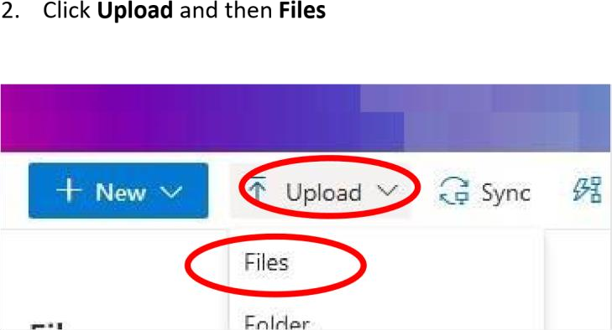
- Navigate to where you saved the file (E.g. Desktop or Documents) and click on the file name it to select it. Click Open.

- A message, like below, should appear telling you the file has now be uploaded.

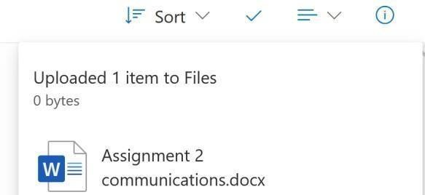

4.2. Sharing files from your OneDrive

- Once you have logged in to your Microsoft 365 Account, click the 9-dot menu grid in the top left-hand corner to expand the app menu and click on OneDrive.

- Open the file or document that you want to share.

- On the top right, click the Share button and in the ‘Send link’ pop-up box, type your recipient email address. Note: Staff email addresses consist of the Teacher’s first initial, then full surname followed by @dcfe.ie .Click Send.

5.0 Printing in DCFE

For use of secure printing in the college building you must use an application (LexMark CloudPrint) and have a Printing PIN. You can use this pin on any printer in the college buildings.

5.1 Generate Your Printing PIN

- Go to: https://cloud.lexmark.com.

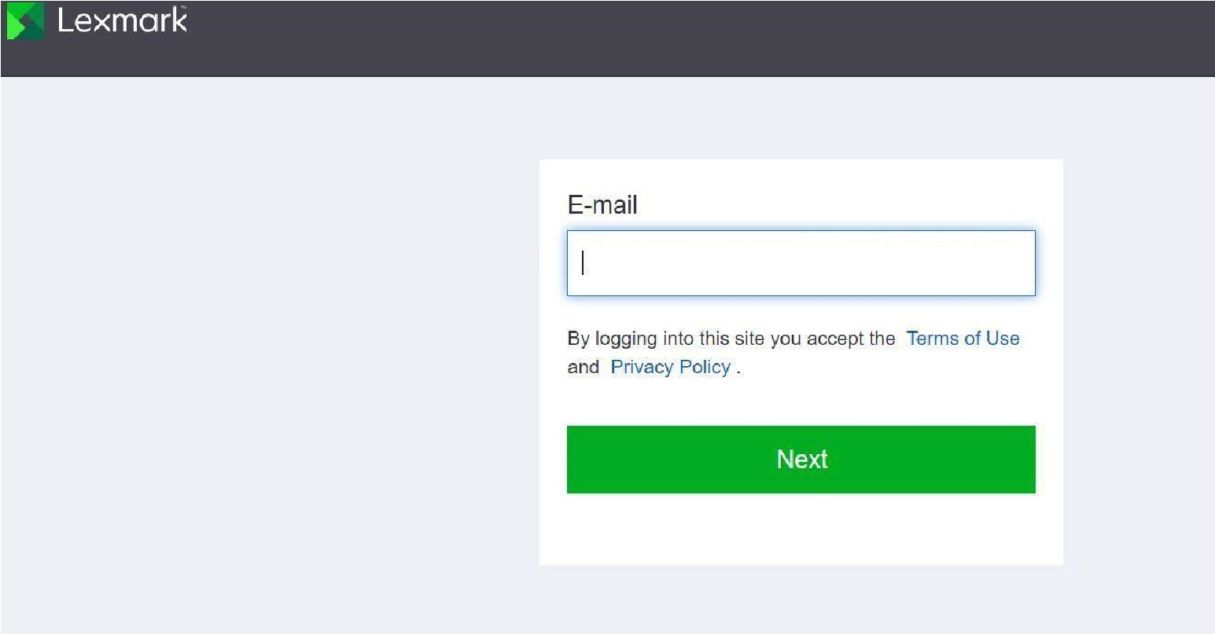
- Type in your email address and click Next

- Go to My Account and click on Set PIN under Printer login section

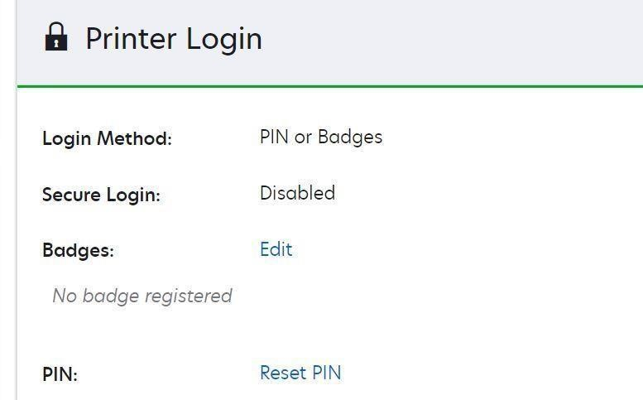

- A new PIN code will be generated and emailed to your college email inbox. (Check your Junk email if not sent to your inbox) You will need this PIN when you are at a printer and want to release what you sent to the print queue so it is advised that you take a photo of this PIN or store it somewhere in your phone.

5.2 Printing through browser

- There are various ways to use cloud print but the easiest way is to directly through the browser .Go to https://cloud.lexmark.com

- If you are not already logged it to your office account you will then be asked to login to your dcfe.ie office account here.

- Go to Print Management from the dashboard and then Print Queue

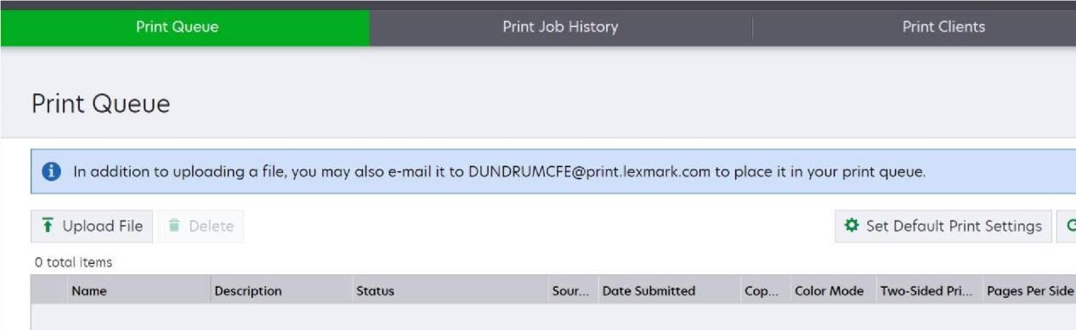
- Click on the "Upload File" and select the file(s) you want to print. They will appear in the queue

If you need to change the default print settings, you can do this by clicking on set default print settings within the Lexmark Portal.

- Go to printer and enter pin and select print release to collect your print outs

Note the desktop may have Cloud Print Management pre-installed like in the following pictures. In this case you can select that Printer and collect your printout from the printer, but you need to be using your PIN

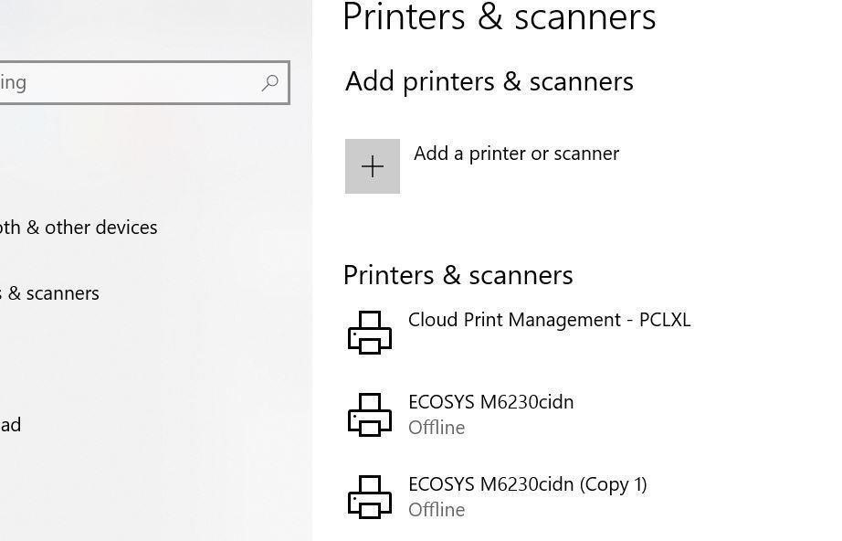

Printing Notes:

The system is configured to automatically delete all unreleased print jobs older than 24 hours.

If you forget your PIN number and can’t find the email from Lexmark: you can generate a new pin by logging into cloud.lexmark.com with your college email address and password. Navigate to "My Account" and under printer login section, click on "Reset PIN". The system will send you a new PIN code to your college email inbox.

6.0 Help & Support

Contact your Programme Lead for initial help and support to any of the topics in this handbook. The Programme Lead will contact IT Support on your behalf for problem resolution.

